**Data Sheet:**

The data suggests that the business is generating significant revenue with total sales of $2,297,200.86, but with relatively low profit margins, indicating a need for operational efficiency improvements. The average order value is moderate at $229.86, but the average profit per order is relatively low at $28.66. Overall, the data indicates a high-volume sales business with room for improvement in profitability.

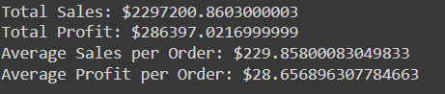

**KPI Sheet:**

The business experiences fluctuations, with profit margins and sales quantities varying across months. The profit margin is highest in October (15.97%) and lowest in July (9.05%). The total profit is highest in December ($43,436.13) and lowest in January ($9,199.27). The number of orders is highest in September (1,386) and lowest in February (301). The business seems to perform better in the second half of the year, with higher profits and order quantities. This could be due to various factors like holiday seasons.

**KPI-YOY Sheet:**

The business shows steady growth from 2011 to 2014, with increasing sales, profit, and order quantities. Profit margin is relatively stable, ranging from 10.23% to 13.41% indicating a healthy business.

**Combo Chart Sheet:**

The business has a clear seasonal trend in sales and profit, with the highest sales and profit in Q4 (Nov-Dec). Sales in Q4 are more than double the sales in Q1 (Jan-Feb), and profit in Q4 is also significantly higher than in other quarters. This trend suggests that the business is likely to be related to a seasonal product or service. The data can be used to plan for the seasonal fluctuations in sales and profit, such as increasing inventory or staffing in Q4.

**Waterfall Chart Sheet:**

The profit breakdown:

* **Office Supplies** generate the highest profit, accounting for approximately 66.7% of the total profit ($9.02K out of $13.51K).
* **Technology** is the second-largest contributor to profit, making up around 30.6% of the total profit ($4.13K out of $13.51K).
* **Furniture** contributes a relatively small amount to the total profit, only about 2.7% ($0.36K out of $13.51K).

XYZ company can optimize the Office Supplies category to maximize profit or exploring opportunities to increase profit margins in the Technology and Furniture categories.

**Donut Chart Sheet:**

* **Furniture** is generating over one-third of the total sales.
* **Office Supplies** is highest contributor, accounting for nearly 38.1% of the total sales.
* **Technology** is making up around 26.8% of the total sales.

Company can boost sales in all categories.

**Map Chart Sheet:**

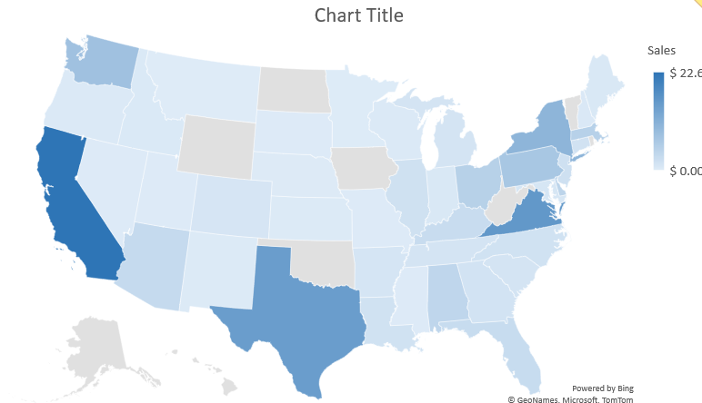

The table shows sales figures for various states, with California, Virginia, and Texas leading in sales with $22.61K, $15.99K, and $14.88K respectively. These states have significant economic activity, likely due to their large populations and diverse industries. Conversely, states like Montana, Minnesota, and Missouri show minimal sales, reflecting smaller market sizes or lower economic activity in those regions.

**Top-5 Sub-Categories Sheet:**

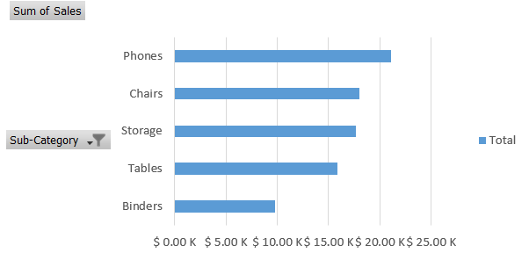

Phones lead in sales with $21.13K, followed by Chairs ($17.99K), Storage ($17.62K), and Tables ($15.90K), while Binders have the lowest sales at $9.81K. The total sales across all categories amount to $82,461.04. This indicates a higher demand for Phones and Chairs, suggesting a focus on these categories for inventory and marketing strategies, while Binders might need targeted efforts to boost their sales.